**Project Proposal**

**Project Name: NavigateNow**

**Group members:**

**Azzam Althunayyan SID: 520160978**

**Jianbin Sui SID: 530592947**

**Shrikant Bipinkumar Kartha SID: 530667382**

**Calvin Li SID: 530701789**

**University Of Sydney**

**ELEC5619 Object-Oriented Application Framework**

**Nan Yang**

**Due date: 03/09/2023**

**Table Contents**

Introduction 2

Background 2

Functional requirements. 5

Non-functional requirements 11

Database design 13

Mockups 14

Project plan 20

Conclusion 22

References 23

# Introduction

This project mainly focuses on creating a Sydney tourism advisory web application for new tourists. The application will provide information including local attractions, transportation, restaurants, weather, etc., in Sydney and offer budgeting assistance, checklist assistance, and help users to form travel groups.

# Background

During the COVID-19 pandemic, international, regional, and local travel restrictions immediately impacted global economies, including the tourism system [1]. Lockdowns on the largest scale in human history have been imposed by governments around the world to control the spread of the pandemic [2]. However, recently, major global economies have legally lifted travel restrictions, paving the way for rapid development in the tourism industry. Taking China as an example, it will stop requiring inbound travellers to go into quarantine starting on January 8, 2023[3]. At the same time, the use of Internet technology in the tourism industry has increasingly become mainstream. In a survey based on hotel guests in Seattle, nearly 80% of the hotel guests used the Internet to search for hotels, whereas less than 5 percent of the respondents consulted travel agents [4].

In the post-pandemic era, if a website can create a convenient travel web application, it's foreseeable that this project will have a very promising outlook. Although current travel-related websites on the market have professional data processing teams that offer comprehensive travel consultation support to users, it’s still obvious that beyond reviews and user forums, these websites don't offer much in terms of user communication features.

To research mainstream travel websites in the market, this proposal gathers information through Similarweb. Similarweb is a platform that puts web information all together through data models. According to the platform's travel website usage rankings [5], the top three are: Booking, TripAdvisor, and Airbnb, see figure 1 below.

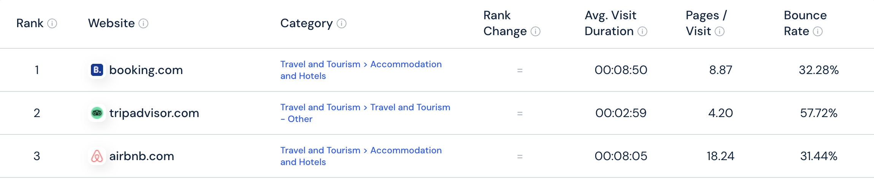

**FIGURE 1. The top 3 travel websites according to Similarweb**

On those websites, Booking and Airbnb primarily offer booking services for hotels, homestays, and other accommodations. They also provide services for purchasing flight tickets, tourist tickets, etc., based on users' destinations, as shown in Figure 2.

On the other hand, TripAdvisor merges attraction information, offering users travel advice related to their destinations and features a forum for users to review attractions.

Therefore, to enhance user interaction, this web application will implement a group feature, assisting users in finding fellow travellers heading to the same destination or forming travel teams with their friends.

Also, for users who are trying to set up a detailed plan for touring, the application offers a tourist plan function. With the chosen interests, the system would generate a few places for users to choose as their plan.

Moreover, mainstream platforms lack basic guidance for users' pre-trip preparations. To assist users in better planning their trips, this website will introduce an expense calculator and a checklist feature.

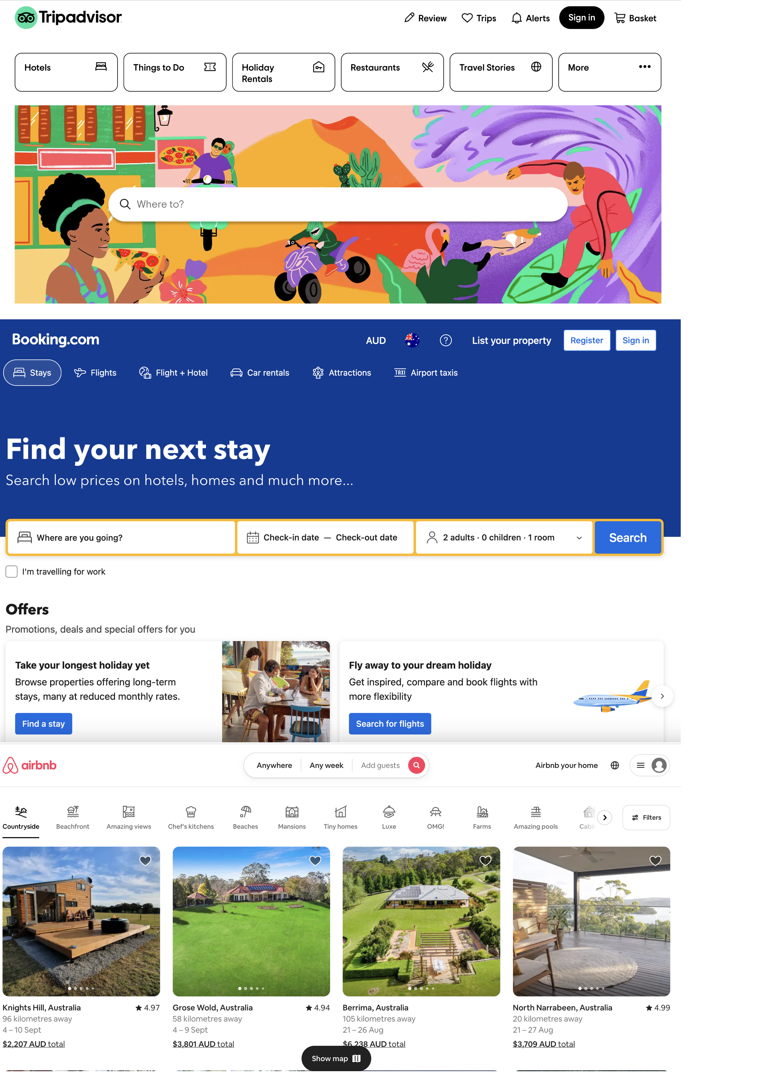

**FIGURE 2. Webpage screenshot of Booking, Airbnb and Tripadvisor**

# Functional requirements.

**Functional Requirement FR-001: User Registration.**

**Description:** The system shall allow users to create an account by providing a valid email address and password to access the platform.

**User inputs:** user email address and password.

**Acceptance Criteria:**

* Users should be able to provide a valid email address and password during registration.
* The system should validate the uniqueness of email addresses to prevent duplicate accounts. If the entered information is not valid, the system should show an error message "The entered email address or password is not valid".

**Functional Requirement FR-002: User Login.**

**Description:** Users shall be able to log in into the system using their registered email and password.

**User inputs:** user email address and password.

**Acceptance Criteria:**

* Users should enter a valid email and the correct password to access the platform.
* The system shall verify user credentials and grant access upon successful authentication.
* If the entered information is not valid, the system should show an error message, "The entered email address or password is not valid."

**Functional Requirement FR-003: Log out.**

**Description**: The system shall allow users to log out of the platform.

**Acceptance Criteria:**

* Users should have been logged into the platform previously.

**Functional Requirement FR-004: General Information.**

**Description**: The system shall provide users with general information about Sydney, such as transportation, emergencies, weather, the process at the airport, and useful links.

**Acceptance Criteria:**

* Users should have been logged into the platform previously.

**Functional Requirement FR-005: Add expenses calculator.**

**Description**: The system shall provide users with an expense calculator template to help them calculate their expenses.

* User inputs: expenses description and cost.

**Acceptance Criteria:**

* Users should have been logged into the platform previously.

**Functional Requirement FR-006: Edit expenses calculator.**

**Description**: The system shall allow users to edit the expense calculator template.

* User inputs: expenses description and cost.

**Acceptance Criteria:**

* Users should have been logged into the platform previously.
* At least one expense must be added.

**Functional Requirement FR-007: Add check list.**

**Description**: The system shall provide users with a check list creator to help them carry the most important stuff before heading into a specific place.

* User inputs: item name, item description.

**Acceptance Criteria:**

* Users should have been logged into the platform previously.

**Functional Requirement FR-008: Edit check list.**

**Description**: The system shall allow users to edit a check list.

* User inputs: item name, item description.

**Acceptance Criteria:**

* Users should have been logged into the platform previously.
* The check list must be created already.

**Functional Requirement FR-009: Offering tourist places.**

**Description**: The system shall provide users with tourist places in Sydney based on their interests.

**Acceptance Criteria:**

* Users should have been logged into the platform previously.
* Users’ interests should be chosen from the multiple interests’ options.

**Functional Requirement FR-010: Add tourist plan.**

**Description**: The system shall allow users to add a tourist plan from the places offered by the system based on their interest in organising the trip.

**Acceptance Criteria:**

* Users should have been logged into the platform previously.
* Users’ interests should be chosen from the multiple interests’ options.
* Users should pick at least one place to add a plan.

**Functional Requirement FR-011: Remove tourist plan.**

**Description**: The system shall allow users to remove a tourist plan.

**Acceptance Criteria:**

* Users should have been logged into the platform previously.
* Users should already be on a specific plan.

**Functional Requirement FR-012: Edit tourist plan.**

**Description**: The system shall allow users to Edit a specific tourist plan by changing some places with others or removing it from the plan entirely.

**Acceptance Criteria:**

* Users should have been logged into the platform previously.
* Users should be already in a specific plan.

**Functional Requirement FR-013: User feedback.**

**Description**: The system shall allow users to give feedback about the platform regarding issues to be fixed, suggest ideas, or give positive feedback by filling out a feedback form.

* User inputs: Name, email address, feedback type and message.

**Acceptance Criteria:**

* Users should have been logged into the platform previously.

**Functional Requirement FR-014: Contact us.**

**Description**: The system shall allow users to contact the owner of the platform by filling out the Contact Us form.

* User inputs: Name, email address, contact number and message.

**Acceptance Criteria:** No acceptance criteria.

**Functional Requirement FR-015: Create profile.**

**Description:** The system shall allow users to create profiles with personal information such as name, age, photo, bio, and gender.

**Acceptance Criteria:**

* Users should have been logged into the platform previously.

**Functional Requirement FR-016: Edit profile.**

**Description:** The system shall allow users to edit profile information such as name, age, photo, bio, and gender.

**Acceptance Criteria:**

* Users should have been logged into the platform previously.
* A user profile must be created first.

**Functional Requirement FR-017: Create group.**

**Description:** The system shall allow users to create a group trip for a specific plan to allow other users to join in.

* User inputs: group name, the limited number of users, and allowed age group.

**Acceptance Criteria:**

* Users should have been logged into the platform previously.

**Functional Requirement FR-018: Remove group.**

**Description:** The system shall allow users to remove a group trip from a specific plan.

**Acceptance Criteria:**

* Users should have been logged into the platform previously.
* The creator of the group is able to remove a specific group, even if there are many users in it.
* Group must be created first.

**Functional Requirement FR-019: Edit group specification.**

**Description:** The system shall allow users to edit a group trip specification for a specific plan, such as group name, limit number of users, and allowed age group.

* User inputs: group name, the limited number of users, and allowed age group.

**Acceptance Criteria:**

* Users should have been logged into the platform previously.
* Group must be created first.

**Functional Requirement FR-020: Show groups.**

**Description:** The system shall be able to show users groups in a page to join in.

**Acceptance Criteria:**

* Users should have been logged into the platform previously.
* At least one group should be created, or the system should show a message "There are no groups".

**Functional Requirement FR-021: Search about groups.**

**Description:** The system shall be able to allow users to search for groups to join in.

**User inputs:** group name, gender, age and date.

**Acceptance Criteria:**

* Users should have been logged into the platform previously.
* At least should be one group created.

**Functional Requirement FR-022: Connect with Google API.**

**Description**: The system shall connect with the Google API to retrieve touristy place information such as pictures, rates, and contact information.

**Acceptance Criteria:**

* Users should have been logged into the platform previously.

# Non-functional requirements

**Availability:** The system should be available 99.99% of the time during normal business hours (8 AM to 8 PM, Monday through Friday) and 99.95% of the time on weekends and holidays.

**Scalability:** The system should be able to manage a 20% increase in concurrent users within five minutes after the load has increased.

**Response Time:** Under normal operating conditions, the system should respond to user interactions (such as button presses) within 300 milliseconds.

**Data Security:** Using industry-standard encryption algorithms, all confidential user data (such as passwords and personal information) must be encrypted both at rest and during transmission.

**User Interface Responsiveness:** The user interface should be responsive and functional on devices with different screen sizes, such as tablets and smartphones.

**Reliability:** The system should be able to recover from a failure in less than five minutes and recommence normal operations with no data loss.

**Load Handling:** The system should be able to support a thousand concurrent users with no breaking 80% of its available resources.

**Maintainability:** The codebase should adhere to coding standards and contain thorough documentation, making it simple for new developers to comprehend and maintain the system.

**Accessibility:** The user interface should adhere to WCAG (Web Content Accessibility Guidelines) level AA standards, to guarantee it is accessible to users with disabilities.

# Database design

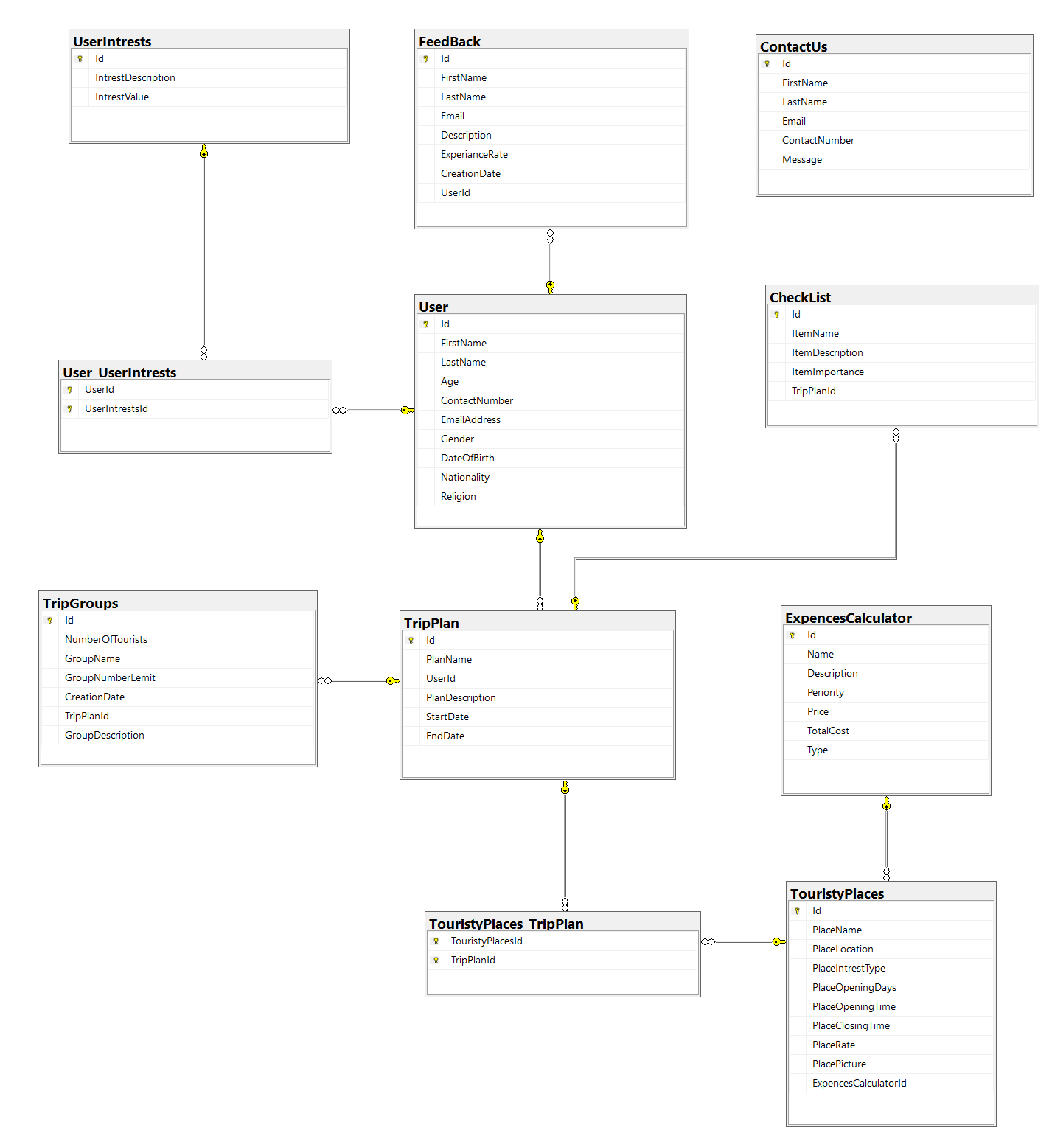

**Figure 3. ERD Diagram**

This ERD diagram is a vision of how the web application database looks like explaining data tables and their relations. As shown in the figure, User data table is the main engine of the database linked with User_UserIntrests data table to store user interests in UserIntrest data table and User_UserIntrests is a lookup table used to represent many to many relationships.

User data table is also connected with TripPlan data table to allow users having many plans based on touristy places offered by the system from TouristyPlaces data table and TouristyPlaces_TripPland data table is used to represent many to many relationships as well as the system offering expenses calculator to help users calculating their expenses for each activity in the plan stored in ExpensesCalculator.

In addition, user might create group for a specific plan to allow others joining and accessing that plan information. Furthermore, the system is offering tourists creating a general check list for the plan that they joined in. As a user, he/she could send feedback via the application stored in FeedBack data table.

# Mockups

The mockups shown in the proposal only represent how every major function works, not the final look of the website.

**Figure 4. User Registration**

Above is a pop-up window for sign-up. By inputting their personal information, users can register through this window.

**Figure 5. User Login**

Above is a pop-up window for login. It requires user’s username and password. After logging in as a member, the main features of the website will be unlocked.

**Figure 6. My Plans -> Checklist**

This is the page of my plans -> checklist with a pop-up of add expenses. It reminds users of the stuff that should bring with them in advance. Also, users can calculate their total expenses and add descriptions to each activity.

**Figure 7. My Plans -> Checklist -> Edit Checklist**

Shown above is the webpage of the edit checklist. It allows users to edit their checklist, which will bring more conveniences.

**Figure 8. My Plan**

This is the page of my plan. Users can see every plan they ever created, with few functional buttons on it.

**Figure 9. Create New Plan -> New Plans**

Above is the page of the tourist plan. This page offers several places based on interests selected by users and generates plans for them.

**Figure 10. User Feedback**

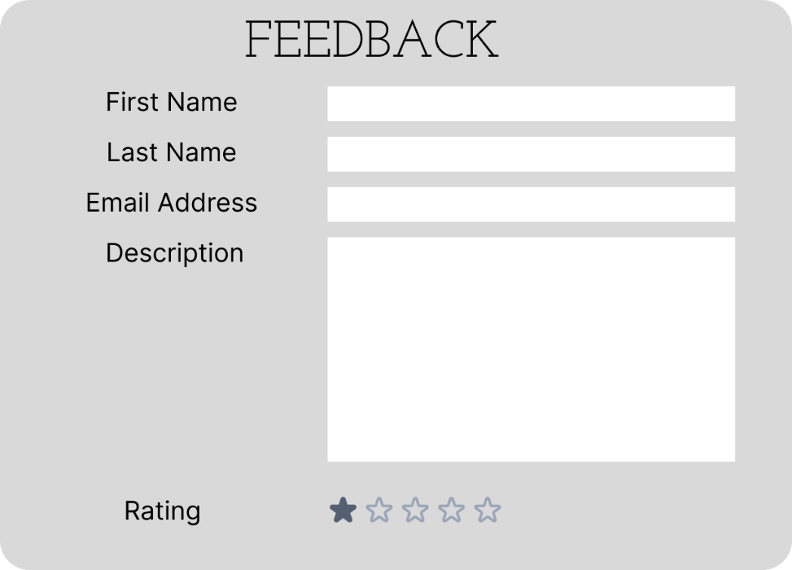

The feedback page is shown above, from which the developers can know exactly how users feel about the website or any technical issues disturbing them.

**Figure 11. Contact Us**

图形用户界面

This is the contact window. It provides a chance for users or potential investors to contact the owner of the website.

**Figure 12. User Profile**

This is the profile page. Users can create their own profiles and edit them whenever they like.

**Figure 13. Groups tab -> By default shows “My Groups”**

Teams

**Figure 14. Groups -> Join Group**

**Figure 15. Popup for CREATE GROUP**

The three figures above show the group function. Users are able to create groups, add group descriptions and specifications.

# Project plan

**Gantt Chart:**

* Start Date: Friday, 1 September 2023
* End Date: Friday, 27 October 2023
* Duration: 49 Days
* Sequencing and dependencies are shown in the figures below.

**Figure 16. Gantt Chart**

**Figure 17. Gantt Chart 2**

**Team member responsibilities:**

|  |  |
| --- | --- |
| Member name | Allocated tasks |
| Azzam Nasser A AI Thunayyan | Design User Registration Interface  Design User Login/Logout Interface  Create User Profile Page  Add Edit Profile function  Design Contact Us Page (via Email)  Design Feedback Page |
| Shrikant Bipinkumar Kartha | Design Offering Tourist Plans List  Design Add Tourist Plans Function  Design Remove Tourist Plans Function  Design Edit Function for Tourist Plans  Add Groups Showing Function |
| Jianbin Sui | Connect with Google API  Add Expenses Calculator  Create Edit function for expenses calculator  Generate Check List  Create Edit check list function |
| Calvin Li | Generate General Information  Add Group Creation Function  Add Searching Function for Groups  Create Remove Function for Group  Edit Group Specification |

# Conclusion

In general, this project will be a tourist website that aims to bring useful tourism-related functions. As changes in the market happened in the past few years, tourists may no longer satisfied with traditional and old-fashioned tourism services, and they are hoping to see new solutions in the industry. With proper design and implementation of digitization, this application should be able to meet the requirements of customers, deliver an outstanding user experience, and provide a sustainable platform that can keep running for years. In the coming future, it’s obvious that this product will succeed and become the priority of users.

# References

[1] Gössling, S., Scott, D., & Hall, C. M. (2020). Pandemics, tourism and global change: a rapid assessment of COVID-19. Journal of sustainable tourism, 29(1), 1-20.

1. Rahman, M. K., Gazi, M. A. I., Bhuiyan, M. A., & Rahaman, M. A. (2021). Effect of Covid-19 pandemic on tourist travel risk and management perceptions. Plos one, 16(9), e0256486.
2. Reuters. (2022, December 26). China to scrap COVID quarantine rule for inbound travellers. *Reuters*. <https://www.reuters.com/world/china/china-drop-covid-quarantine-rule-inbound-travellers-jan-8-2022-12-26/>
3. Jordan, E. J., Norman, W. C., & Vogt, C. A. (2013). A cross-cultural comparison of online travel information search behaviors. Tourism Management Perspectives, 6, 15-22.
4. Similarweb. (2023, March). *Similarweb.com - Digital World Market Intelligence Platform*. SimilarWeb.com. https://www.similarweb.com/top-websites/travel-and-tourism/